
Mestrado em Engenharia Informática 2025/2026

Machine Learning

Milestone 1

Edgar Almeida

Rodrigo Duarte

09 November 2025

Data Overview

The dataset chosen for this milestone contains information about risk factors used to predict the risk of heart disease. It was obtained on Kaggle (https://www.kaggle.com/datasets/fedesoriano/heart-failure-prediction/data) and represents a supervised learning environment, once our target feature is already present in our dataset.

It is composed of 918 instances and 12 attributes and describes information about patients, aiming to predict the likelihood of heart failure. A summary of the attributes is shown in figure 1:
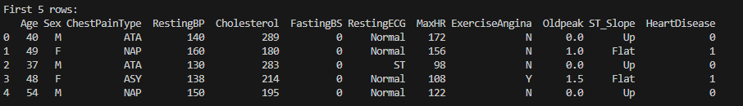
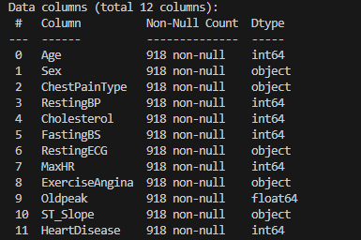

Figure 1: Attributes description including names, data types and non-null counts.

Figure 1 demonstrates that each instance represents a patient’s medical information and if they either have a heart disease or not (1 indicates heart disease and 0 indicates the absence of heart disease).
It also reveals the attributes datatypes, where ‘Age’, ‘RestingBP’, ‘Cholesterol’, ‘FastingBS’, ‘MaxHR’, ‘Oldpeak’ and ‘HeartDisease’ are numerical attributes and ‘Sex’, ‘ChestPainType’, ‘RestingECG’, ‘ExerciseAngina’m and ‘ST_Slope’ represent categorical attributes.
There are no missing data and no duplicate instances in the dataset, meaning that all attributes have complete data.

Regarding the statistical summary of the numerical features of this dataset, its overview is displayed on figure 2.
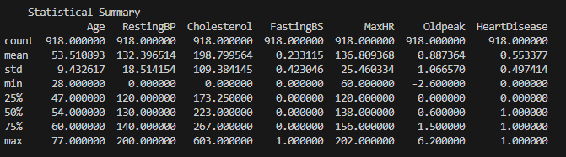
Figure 2: Statistical Summary regarding the numerical features of this dataset.

As displayed on Figure 2, the dataset shows that the average patient is about 53.5 years old, with ages ranging from 28 to 77, which aligns with typical heart disease risk demographics.
Resting blood pressure averages around 132.4 mmHg, though it varies quite a bit — some records even show values as low as 0 and as high as 200. Cholesterol levels also show wide variation, averaging roughly 199 mm/dl but ranging from 0 all the way up to 603 mm/dl. It is known that Cholesterol and Resting blood pressure can’t have values of 0, meaning that this values probably corresponds to missing data.
When it comes to fasting blood sugar, the average value is 0.23 mg/dl. That means that around 23% of the patients have elevated fasting blood sugar levels (above 120 mg/dl).
The maximum heart rate (MaxHR) achieved by patients averages about 137 beats per minute, ranging from 60 to 202 bpm, which shows the wide diversity in cardiovascular capacity among the group.
Oldpeak has an average of 0.89, but some patients recorded negative values down to -2.6 and others as high as 6.2, indicating differing levels of cardiac stress responses.
On average, about 55% of the individuals in this dataset have been diagnosed with heart disease, meaning slightly more than half of the participants are positive cases.
Looking at the overall distribution, half of the patients are between 47 and 60 years old. Their resting blood pressure typically falls between 120 and 140 mmHg, and cholesterol levels for most patients are between 173 and 267 mg/dl. Almost all patients have normal fasting blood sugar levels (a value of 0). The typical maximum heart rate is around 138 bpm, and the median Oldpeak value is about 0.6. Roughly one out of every two patients in the dataset has heart disease.

Data Visualization and Outlier Detection

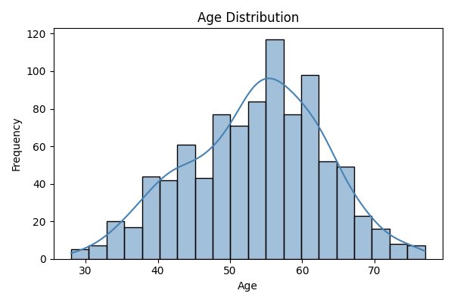
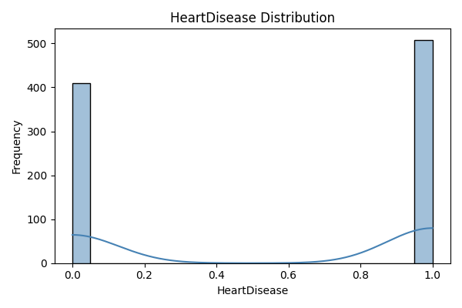
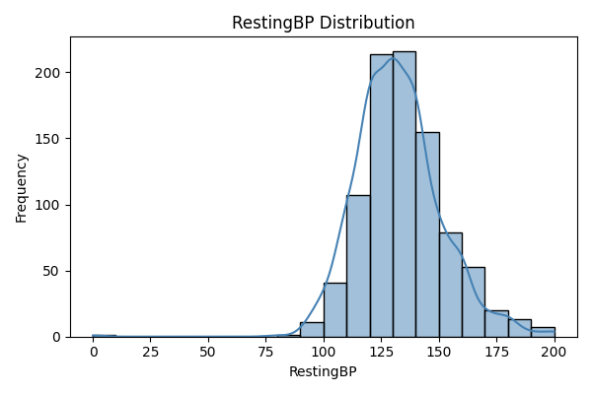
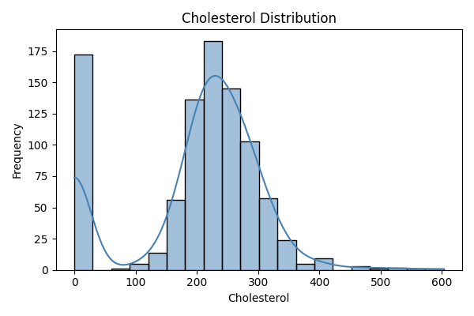
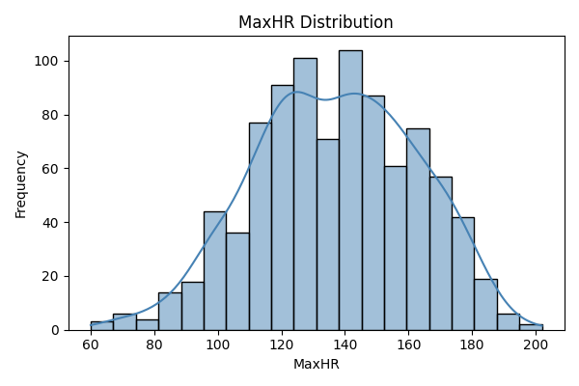
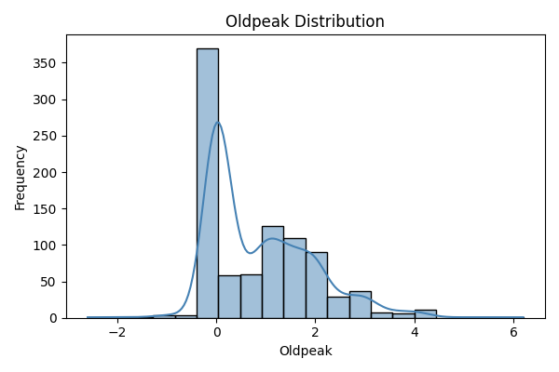
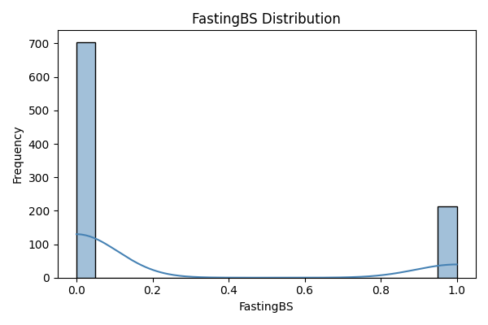
For better understanding of the distribution of the numerical variables in our dataset, we display the data in a histogram format, represented in Figure 3.

Figure 3: Histogram charts for the numerical variables.

Figure 3 allows us to visualize the frequency distribution of our numerical data, revealing patterns like spread, central tendencies, skewness and kurtosis. The last two represent measures of the shape of a distribution and the values obtained for the numerical variables can be seen in Figure 4.

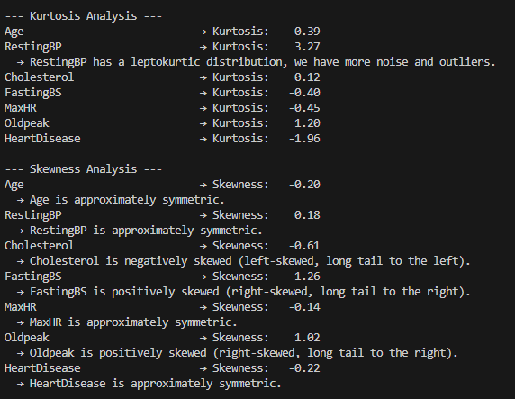
Figure 4: Kurtosis and Skewness of the numerical features.

By analyzing the values of kurtosis, one feature highlights from the rest of the variables. When the value of kurtosis is higher than 3, we are in the presence of a leptokurtic distribution, which ‘RestingBP’ falls in category. That can be visualized in the features histogram (Figure 3), once the peak is higher and sharper than a normal distribution would have. This measure is an indicator of possible outliers and noise in the dataset.
Regarding skewness, values lower than -0.5 indicates that the distribution has a long-tail to the left, which means it’s left skewed (as is the case of ‘Cholesterol’) and values higher than 0.5 indicates that the distribution has a long tail to the right – it’s right skewed (which is the case of ‘FastingBS’ and ‘Oldpeak’).

Another way to see data distribution is through boxplots. This type of chart allows to easily visualize data’s dispersion through metrics like quartiles, median, inter-range quartiles and also makes it possible to detect any potential outliers. Given that, the box-plot charts for our numerical variables are represented in Figure 5.

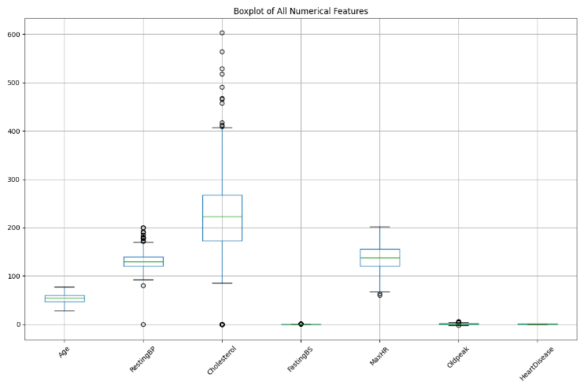
Figure 5: Boxplot chart for dataset’s numerical features.

By evaluating Figure 5, we can see that our data have outliers for the features ‘RestingBP’, ‘Cholesterol’, ‘FastingBS’, ‘MaxHR’ and ‘Oldpeak’. It was made the following observations regarding outliers in our data:
- RestingBP: 28 outliers were detected.
- Cholesterol: 183 outliers were detected.
- FastingBS: 214 outliers were detected.
- MaxHR: 2 outliers were detected.
- Oldpeak: 16 outliers were detected.
- Age and HeartDisease did not contain any outliers.
Despite these outliers, they were retained in the dataset for now as they might represent real extreme cases relevant to heart disease diagnosis.

Lastly, we can try and see the correlation of our features using a heatmap correlation technique, which helps analyze relationships between variables. Figure 6 represents the corresponding heatmap for our features.
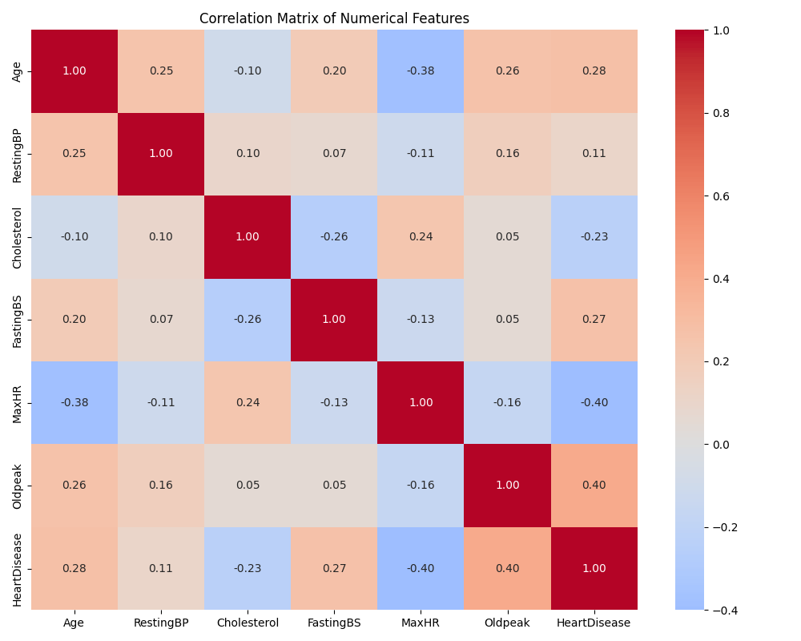
Figure 6: Heatmap for datasets’ numerical features.

By assessing this heatmap we can conclude that:
- ‘Age’ and ‘MaxHR’ have a slightly moderate negative correlation, meaning that the older someone gets, the lower is their maximum heart rate.
- ‘Oldpeak’ and ‘HeartDisease’ have a slightly moderate positive correlation, meaning that higher the oldpeak is, the higher is the chance of heart disease.
- ‘MaxHR’ and ‘HeartDisease’ have slightly moderate negative correlation meaning that lower maximum heart rate is associated with higher chance of heart disease.
- ‘Age’ and ‘HeartDisease’ have weak positive relationship meaning that older individuals are more likely to have heart disease.
- ‘FastingBS’ and ‘HeartDisease’ have a weak positive correlation meaning that individuals with high fasting blood sugar have higher risk for heart disease.
- ‘Cholesterol’ and ‘HeartDisease’ have a moderate negative correlation, which may be justified by the null-count.

Train-Test Split

Data was split into training and test sets, with 80% of data (corresponding to 734 instances) used for training the model and 20% (184 instances) used for testing.

After the split, our target feature had the following distribution:
- Training Set (734 instances):
  - 401 individuals with heart disease (1).
  - 333 individuals without heart disease (0).

- Test Set (184 instances):
  - 107 individuals with heart disease (1).
  - 77 individuals without heart disease (0).

Data Preprocessing and Transformation pipelines

This section will be used to discuss the preprocessing and transformation that our data went through. Initially, our features were separated by their datatype (either numerical or categorical). Then, we needed to work on the ‘0’ values for ‘Cholesterol’. To do that, we used a Custom Transformer to replace the ‘0’ values with ‘NaN’ values, so they can later be imputed.
Afterwards, we start the scaling and the imputation of our numerical data. To impute our numerical data, we used the median value of the feature and then we scaled our data using StandardScaler. These were selected because they are not significantly inlfuenced by the presence of outliers.
When it comes to categorical data, we used a simple imputer using our most frequent value for that feature, to impute data (in this case there was no missing values for categorical features) and afterwards, we used OneHotEncoder to encode our data.
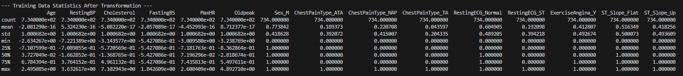
To finish it all, we combine all transformations and applied them to rebuild the dataframe, resulting in a 15 features dataset with their statistics shown of Figure 7.
Figure 7: Training Data Statistics after transformation.

Now that the data has been cleaned, encoded, and scaled, it is ready to be trained by a model. All missing values have been handled, categorical features have been encoded into numerical, and numerical features have been standardized. The dataset has also been split into training and testing sets, so it can be used to build and evaluate models to predict heart disease.

